No. of Pages  A | 4
No. of Questions | 3

Department of Computer Science and Engineering
MIDTERM EXAMINATION FALL 2016

CSE421\EEE465: Computer Networks
Total Marks: 45 Time Allowed: 50 minutes
- Answer ALL THREE (3) questions
- Figure in bracket [] next to each question indicates marks for that question

Question 1
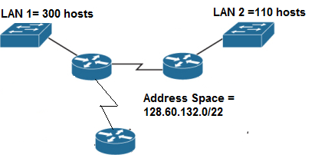
Figure no. 1

- Suppose a company is given a block 128.60.132.0/22, but you need four more sub networks for your organization as shown in Figure no. 1. Show how you can have 4 more subnets out of the original network address as per host requirements. Do not forget to show basic calculations. [8 marks]
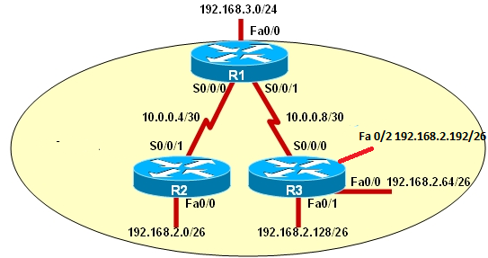
Figure no. 2

- Refer to the above Figure no. 2, a summarized static route has been configured in Router R1
R1(config)# ip route 192.168.2.0 255.255.255.0 s0/0/1

Will this command create a problem, yes or no and why? [4 marks]

- A router has the following information regarding the network 172.17.10.0/24, which one will it use to routes packets to that destination and why? [3 marks]
  - S 172.17.10.0/24 [1/0] via 200.20.20.1
  - S 172.17.10.0/24 [5/0] via 201.21.20.1

Question 2

- A switch uses dynamic VLANs assignment. Three workstations are connected to the same switch port fa0/2 by using a hub. The workstations will under different VLANs, true or false, explain? [3 marks]
- Refer to the exhibit shown in Figure no. 3 below,
  - What does the “dot1q” refer to?
  - Is there any problem with the configuration?
  - If the router receives a packet with the destination address of 192.168.10.70/26 and another packet with the destination address of 200.20.20.200/26, which sub-interface/s will the router use to send the packets? Explain your answer in one line. [1 mark+2 marks+4 marks]
R(config)#interface f0/0.100
R(config-subif)#encapsulation dot1q 100
R(config-subif)#ip add 200.20.20.68 255.255.255.192
R(config-subif)#interface f0/0.200
R(config-subif)#encapsulation dot1q 200
R(config-subif)#ip add 200.20.20.196 255.255.255.192
R(config-subif)#interface f0/0.300
R(config-subif)#encapsulation dot1q 333
R(config-subif)# 200.20.20.4 255.255.255.192
R(config-subif)# interface f0/1
R(config-if)#no shutdown

Figure no. 3

- A switch can be used for Inter-VLAN routing, how? [2 marks]
- In a VLAN enabled network, what measures can be taken to prevent VLAN Hopping Attack? [3 marks]

Question 3
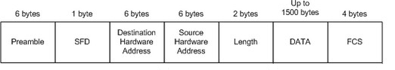
Figure no. 4

- Using the above Figure no. 4 of an Ethernet frame, indicate up to which field do the three types of switching mode allows the switch to read before forwarding? Draw your answer. Which mode has the highest latency and why? [4 marks]

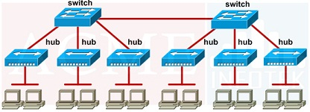
Figure no. 5

- Refer to the above Figure no. 5, how many collision domains and broadcast domains are there? [2 marks]

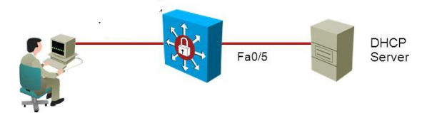
Figure no. 6
S1(config)# interface fastethernet 0/5
S1(config-if)# ip dhcp limit rate 25
- Refer to Figure no. 6, what is the purpose of the commands given to the port fa0/1 of Switch S1? What will these commands prevent from happening? [3 marks]
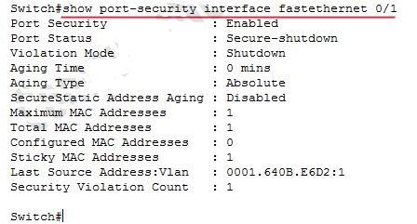
Figure 7

- Refer to output shown in Figure no. 7,
  - What is the port status?
  - A person tries to access the network using a PC with the MAC address 0001:5410:DC12 through port fa0/1. Will he be able to or not?
  - The person restarts the switch and then tries again, will he be able to? [1 marks+2 marks +3 marks]

THE END

